SONY PAYMENT MERCHANT@

Step 1: Go to link: <https://www.test.e-scott.jp/merchant/terminal.jsp?jigysyaCode=00011438>

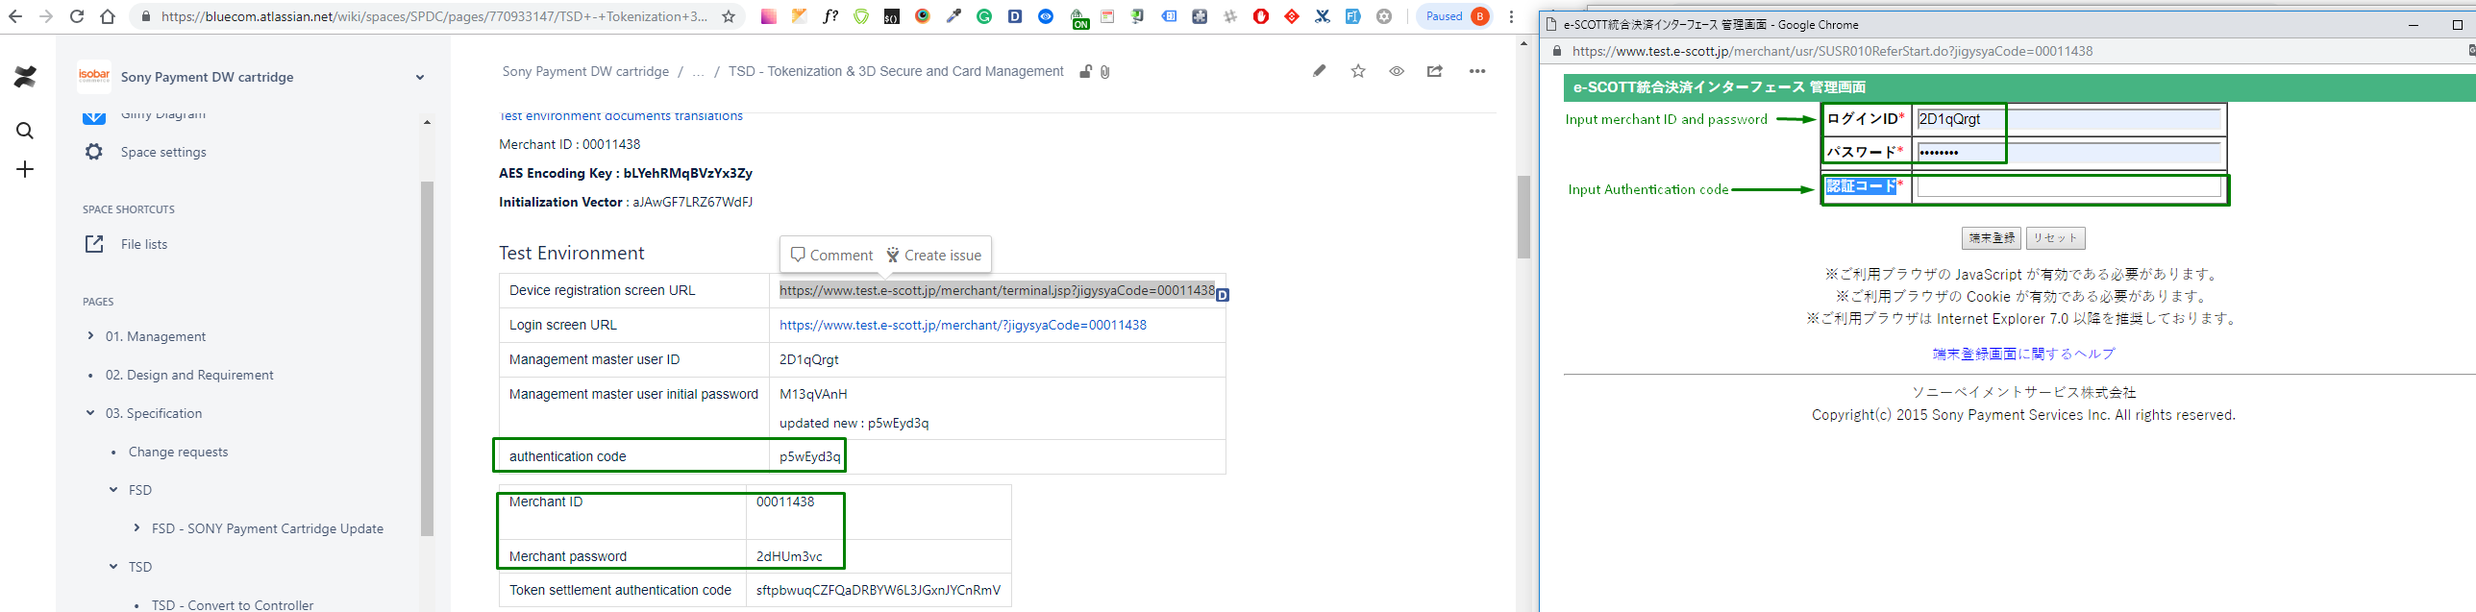

Click Apply button on the left side

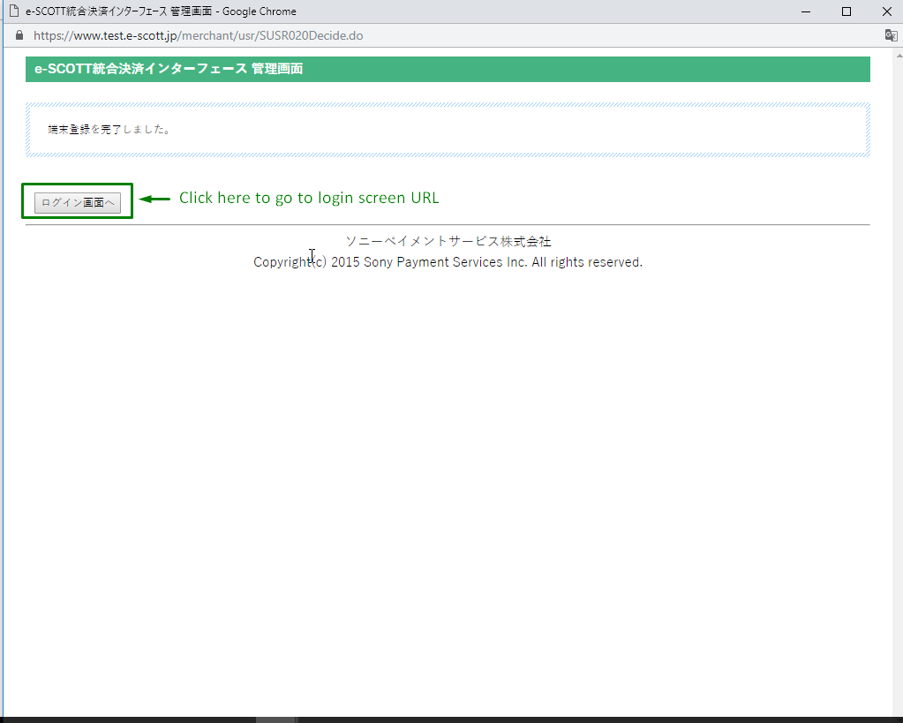

Step 2: After registration is completed. User is redirected auto Login screen URL

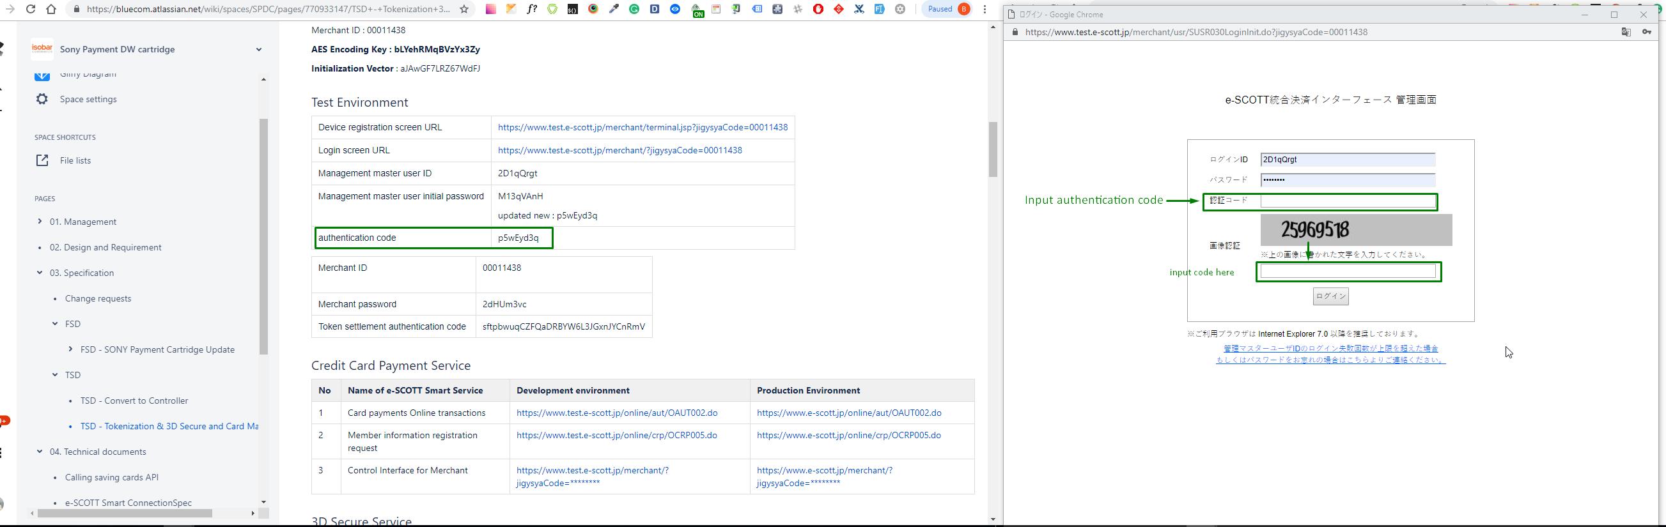

Click SUMBIT button. Redirecting to Homepage merchant as below:

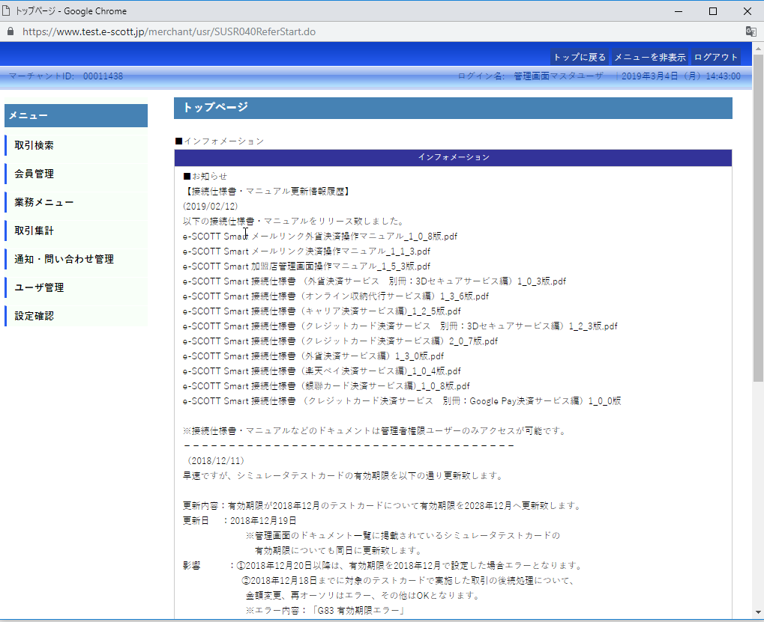

Step 4: Search Order ID to view detail order status

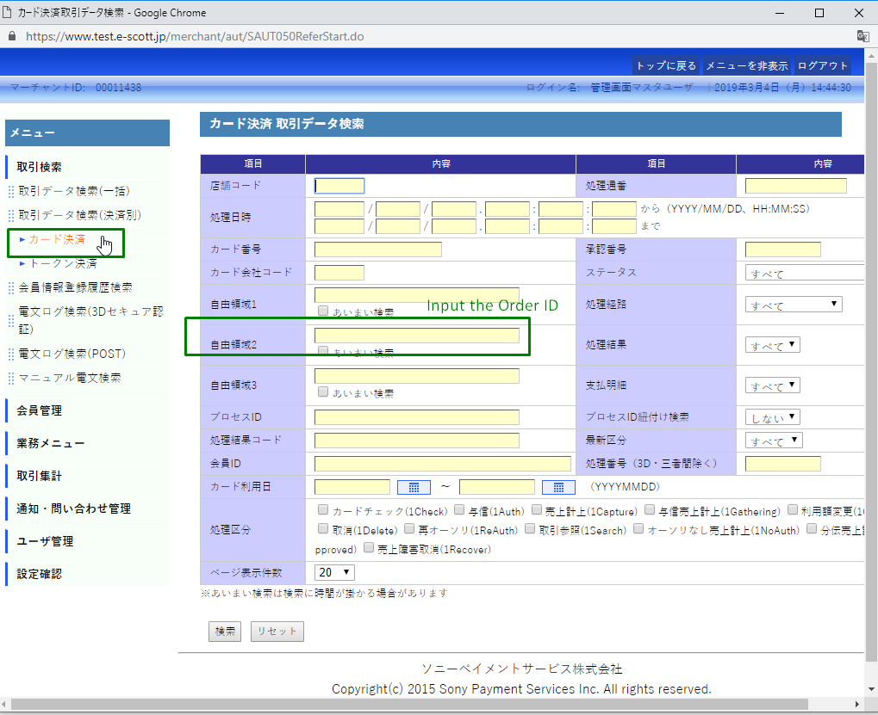

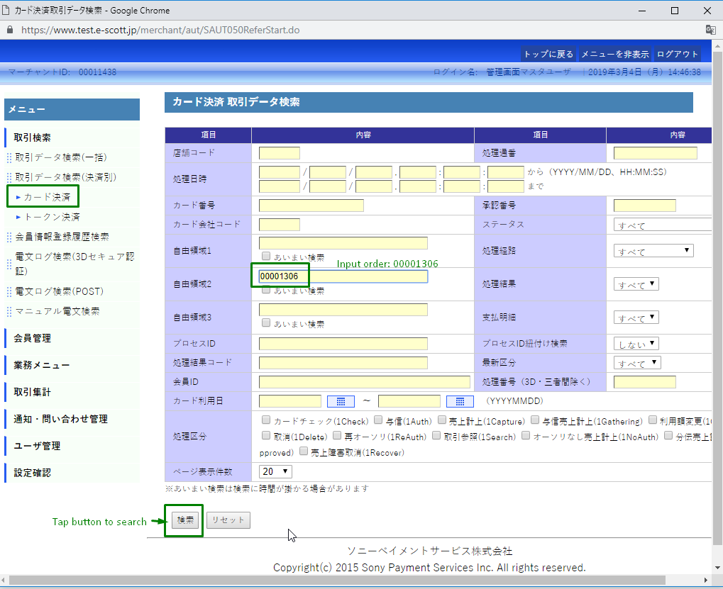

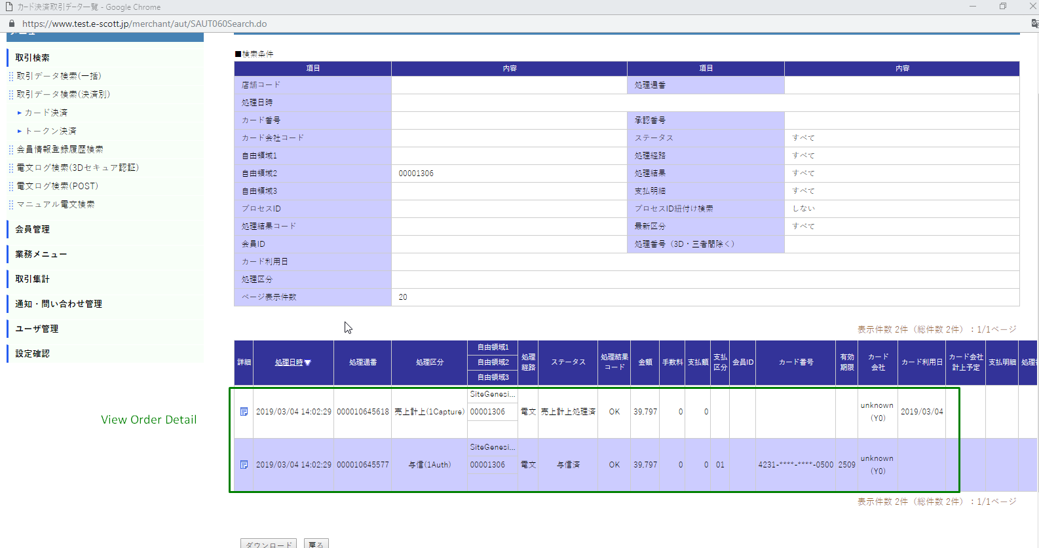

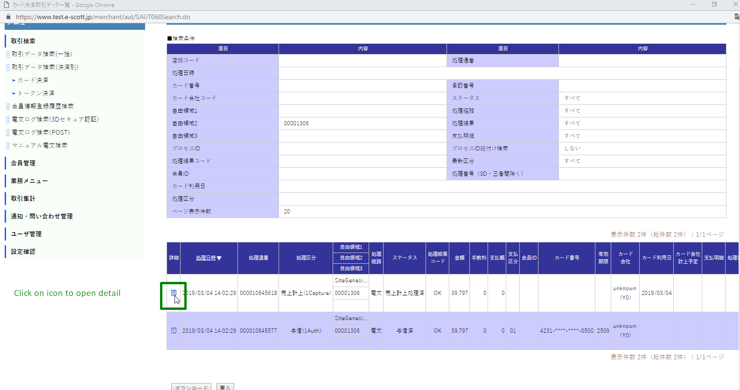

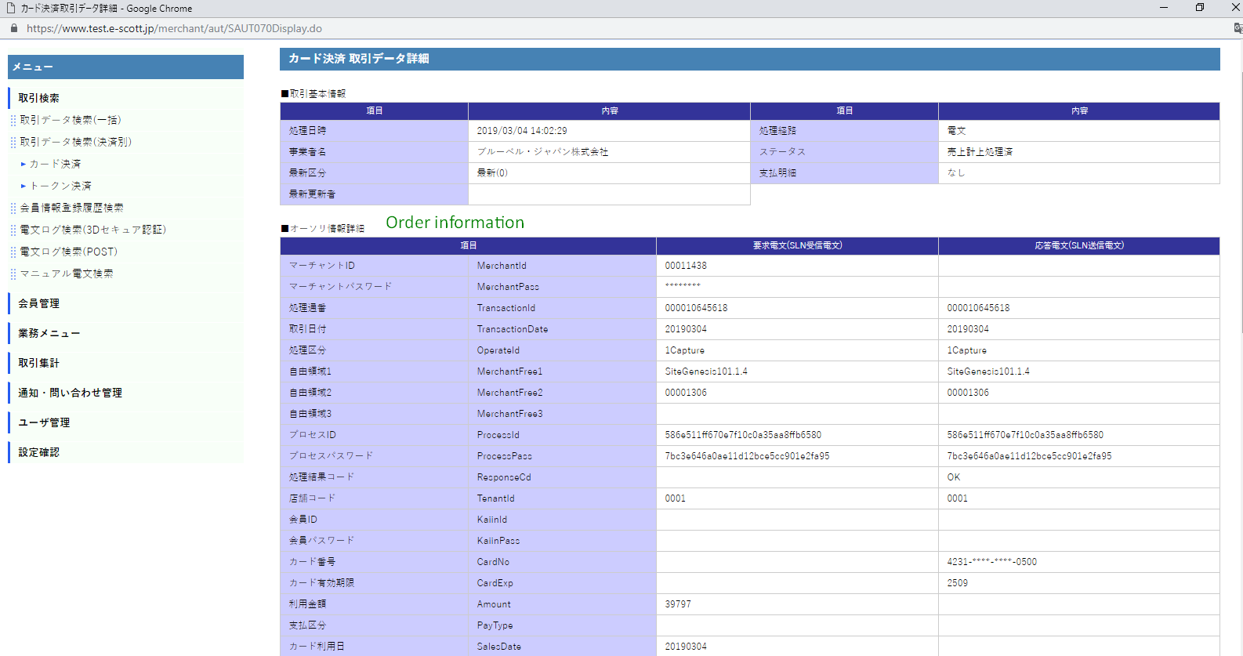

Step 5: User want to Refund

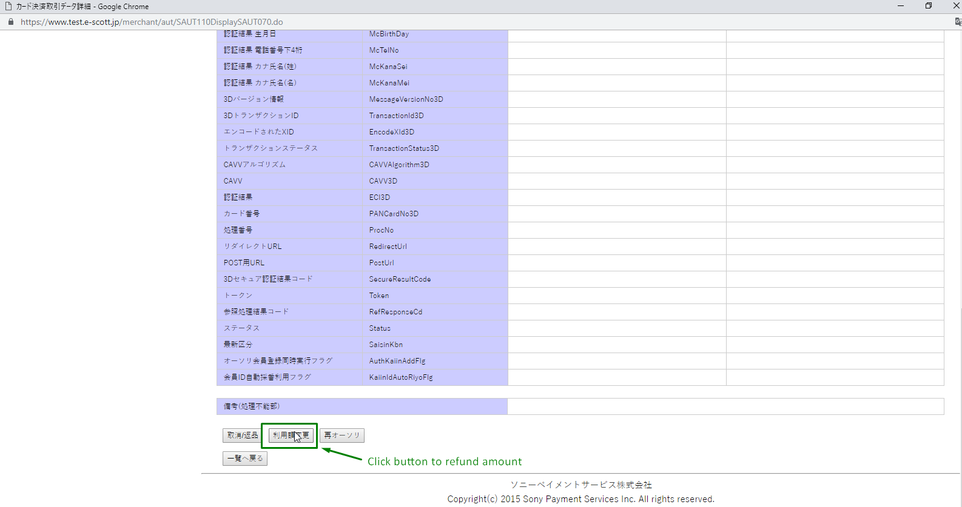

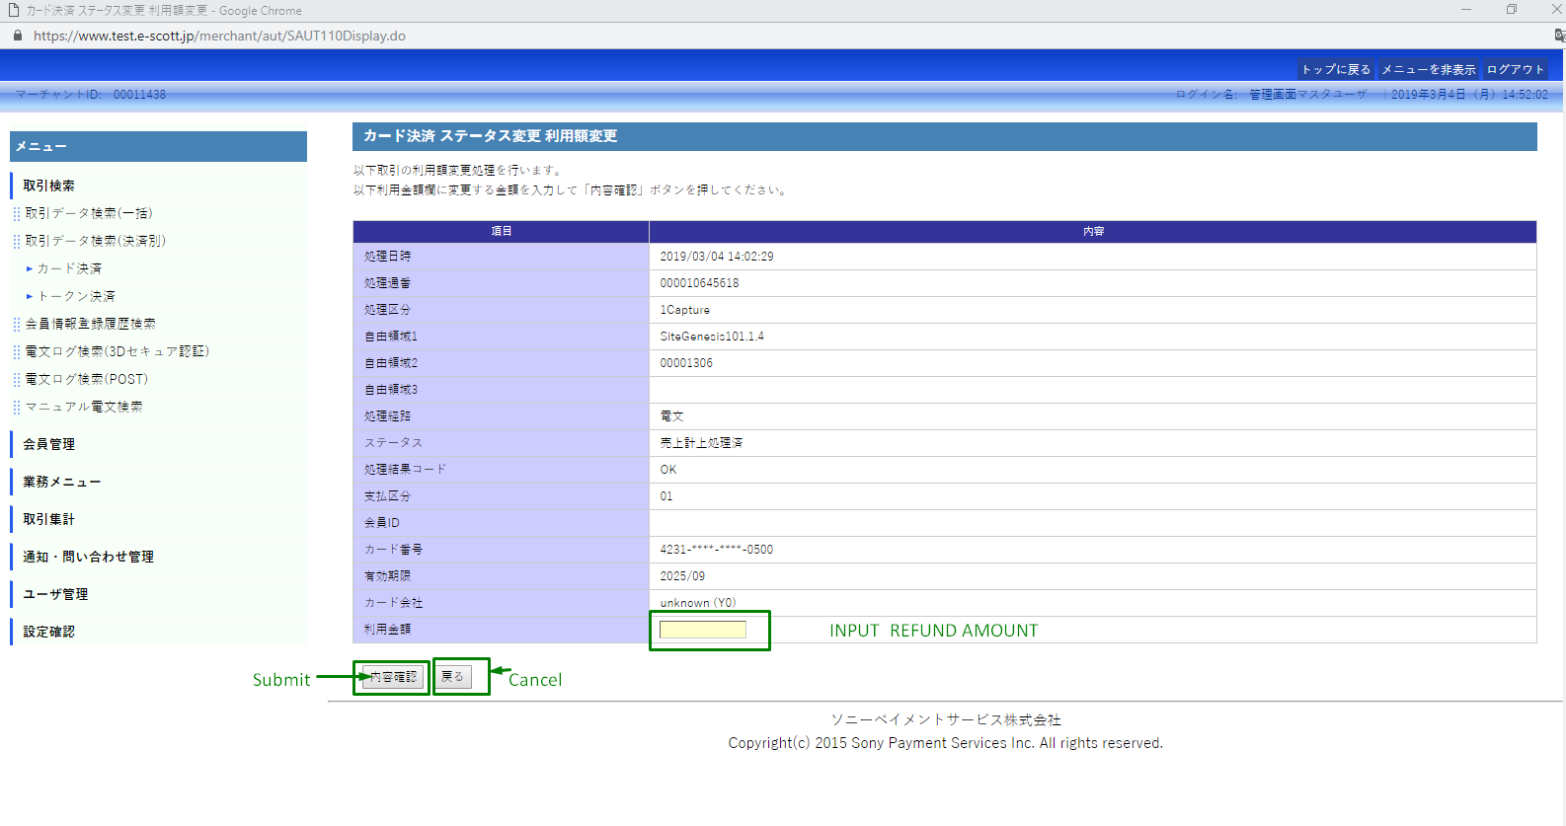

Step 6: If user want to cancel order:

